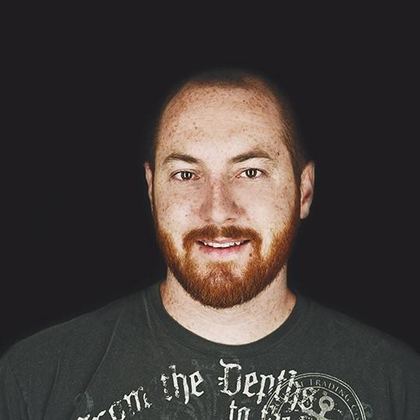Nathan Brown

Senior Software Engineer

Lake Forest, CA

+1 (949) 923-5228

[nathan@nathanrbrown.dev](mailto:nathan@nathanrbrown.dev)

<https://www.nathanrbrown.dev/>

# Summary

Veteran **Software Developer** with experience in data flow, software architecture, live operations, DevOps, back-end programming, mentoring, and coaching.

Approaches problems from a 'customer experience first' approach, designing and executing pragmatic changes that influence the organization as a whole.

Enjoys collaborating with coworkers of all seniority and disciplines to help advance individual growth, ability, and customer experience.

# Work experience

## Senior Software Engineer (2018-2024), Software Engineer (2015-2018) 2015 - 2024

### Microsoft/Blizzard Entertainment, Irvine (caught in a corporate level layoff)

 Managed two internships from screening to extending an offer, to the interns' main point of contact and guide, to fully onboarding when hired as a regular employee

 Learned Puppet, Hiera, Terraform, r10k, and Hiera-Eyaml as part of a multi-stage process to migrate 5+ products from a deprecated and insecure hosting and pipeline solution, to the more modern solution

 Co-championed cross-architecture build pipelines, both to support flexible deployment strategies, and local development environments

 Added Docker and Docker Compose support and documentation for local development and production deployment to 5+ enterprise and public products, reducing project creation, onboarding, and cross-project context switching time by an average of 80%

 Assumed ownership of and acted as a subject matter expert (SME) for an existing, in-house, content management system, serving 100s of legal documents to 20+ unique surfaces in up to 16 languages worldwide

 Took ownership of, and consulted as the SME of a batch processing system, supporting the launches of 14 individual titles over a 7 year period

 Onboarded 16 new team members spread across 3 disciplines over a period of 7 years to a portfolio of 10+ projects

 Represented Blizzard at the 2019 BlizzCon convention as a Codecraft Panelist, responding to engineering questions from the crowd, as 1 of 5 panelists from different teams within Blizzard

 Represented Blizzard in both Blizzard Developer Forums and a community run Blizzard API Developer Discord server for 6 years

 Migrated outsourced Public Developer Portal in-house, using a bespoke project to render the documents, including monthly data updates from stakeholders, with zero downtime

 Planned, coordinated, and led team building events for 10+ people on a monthly basis for ~4 years

 Profiled and optimized APIs with 1,000s of permutations, In preparation for 15 million new hits per month, including a peak of over 14,000 hits per second, increasing responsiveness by 280,000%

 Added industry-standard observability and performance tracking for 10+ unique services by drafting architecture and deployment changes, requiring zero code changes and zero downtime

**Technologies:** Java, Spring, Spring Boot, Spring Data, Spring Batch, Spring Cloud Config, Maven, Oracle, OpenStack, AWS, ArgoCD, Jenkins, Groovy, Node.js, Docker, Docker Compose, Docker Build, CMS, Contentstack, TridionSDL, Puppet, Hiera, Hiera-Eyaml, r10k, Terraform, Git, Windows, OSX, Linux

**Titles:** Warcraft Rumble, Diablo IV, Overwatch 2, Diablo Immortal, Overwatch, StarCraft II: Legacy of the Void, World of Warcraft: Dragonflight, World of Warcraft: Shadowlands, World of Warcraft: Battle for Azeroth, World of Warcraft: Legion, Warcraft III: Reforged, Diablo II: Resurrected, StarCraft: Remastered, World of Warcraft: Classic

**Senior Software Engineer** 2015 - 2015

### Red5, Irvine

 Implemented resiliency measures for 2 of Firefall MMO game services  Developed a load testing framework for 5 Firefall MMO game services

**Technologies:** Git, Windows, Linux

**Titles:** Firefall

**Senior Software Engineer** 2014 - 2015

### Envoy, Irvine (Project ended in 2015)

 Architected and co-authored continuous data import services to back a multimedia smart remote for Envoy's client, Vizio

**Technologies:** Python, Django, Redis, Postgresql, Java, MongoDB, Git, OSX, Linux

**Senior Software Engineer** 2013 - 2014

### Channel Factory, Irvine (Orange County office closed in 2014)

 Implemented a continuous data import service to collect and process millions of records daily to provide 5+ desired statistics for all clients of the AdTech platform

Technologies: Python, Django, Redis, Postgresql, Heroku, VirtualBox, Git, Windows, Linux

## Quality Assurance Analyst (2011-2013), Temporary Assignment: Online Products: Web team (2008), Technical Support Representative III (2005-2011)

**Blizzard, Irvine**

2005 - 2013

**Note:** While titles at the company were as stated, responsibilities from 2008 and later better align with an *Associate* to *Mid-level Software Development Engineer*

 Transformed the way over 13 teams, developed on the Battle.net platform by designing, developing, and deploying a web-based account management tool, reducing request turnover from days to self-service and instantaneous

 Collaborated to create a performance checking application for Diablo III, identifying frame rate losses in over 1000s of zone permutations and 100s of abilities

 Developed a test-server-status tool, representing the state of 4 environments, and 2 to 100+ servers collectively for the Diablo III development team

 Mentored a team of 3 on best practices, code reviews, and defining project scope

 Authored, sustained, and off-boarded a call center performance history dashboard for both employees and managers, serving over 100 representatives and 3+ managers over two locations daily

**Technologies:** Python, C#, AutoIT, Git, Windows, Linux

**Titles:** Diablo III, StarCraft II: Heart of the Swarm, StarCraft II: Wings of Liberty, World of Warcraft: Mists of Pandaria, World of Warcraft: Cataclysm, World of Warcraft: Wrath of the Lich King, World of Warcraft: The Burning Crusade

# Education

## DeVry University

**Major in Computer Information Systems**

# Skills

### Java, Spring

10 **Linux**

10 **Docker, Docker Compose** 8

From monolith to microservice app experience; from greenfield to legacy support

Varying flavors and distributions, predating professional career, both for desktop and server uses, on amd64, x86_64, and arm64v8 architecture

Both for local development and as deployable artifacts

### Jenkins, Groovy

6 **AWS, Openstack, ArgoCD**

5 **Python** 5

Setting up, maintaining, and iterating on deployment pipelines

Combined a mix of bespoke and industry-standard tools to manage 3+ environments of deployments of applications

Both as a backend service and local scripting